Program: Pre-Health Sciences and Healthcare management

Course: Mathematics for Health Sciences II

Course Code and Section Code:S23: PH2003-G3

Last name: Saini

First name: Harita

Student ID: 202200389

Date of Submission: July 3, 2023

Instructor: Omid Rezania

The heart attack dataset mentioned contains 12 features and a binary target variable. Here's a summary of each feature:

* Age: The age of the patient (numerical).
* Sex: The sex of the patient (0 for female, 1 for male).
* Ejection Fraction-The amount of blood pumped by heart
* Blood Pressure: The patient's resting blood pressure (numerical).
* Serum Cholesterol: The level of serum cholesterol in mg/dl (numerical).
* Fasting Blood Sugar: Fasting blood sugar level > 120 mg/dl (1 for true, 0 for false).
* Creatinine phosphokinase-It is the enzyme in the body .High levels means injury or stress to muscle tissue,the heart or the brain.
* Platelets- cells which form clots inside the body.
* Anaemia- Having low red blood cells.
* Serum sodium- Amount of sodium in your body.
* Serum creatinine-amount of creatinine in the body.
* Smoking- patient who smoke .
* Death - number of deaths among patients which have heart attack (1) and 0 who do not have heart attack.

This dataset can be used to build predictive models to determine the risk of heart attack based on the given features. Machine learning algorithms can be trained on this data to learn patterns and make predictions. The target variable will serve as the dependent variable, while the other features will be used as independent variables for prediction purposes.

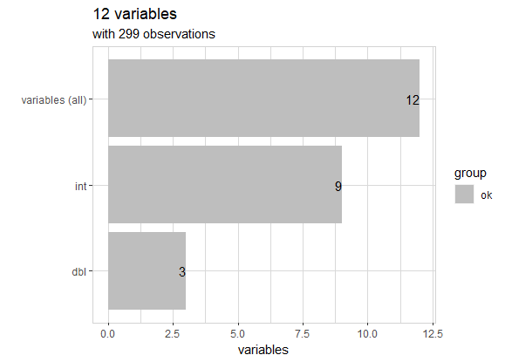

Out of 12 variables, 9 have integer values, while others have double precision floating point .

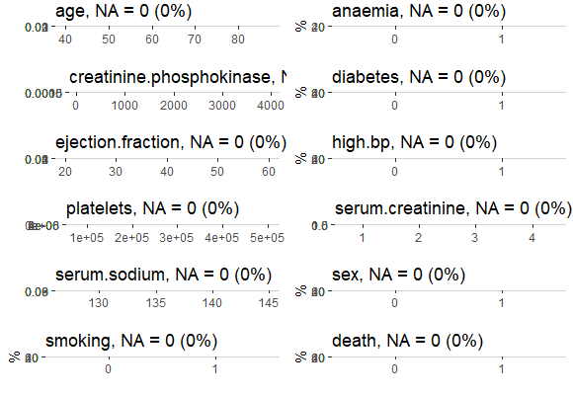

The above graph represents a graphical representation of the data considered, from minimum to maximum values.

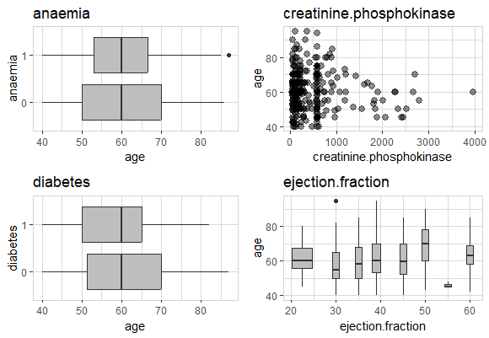

1. Anaemia vs. Age- It is observed that the majority of the patients do not experience a heart attack, and there age ranges from 50 to 70 years old, whereas the patients are 55 to 65 years old and experienced a heart attack. It is found that 60% of patients with anemia do not significantly experience a heart attack.

2. Diabetes vs. Age- According to the data from patients who are 55 to 70 years old, 58% of the total patients do not experience a heart attack, while 42% of the patients who experience a heart attack range from 50 to 65 years old. It is observed that diabetes patients of lower ages are at higher risk of heart attack.

3. Ejection fraction vs. Age- The normal range for ejection fraction lies between 52 to 74% . From the graph, it is certain that majority of the patients have a midly abnormal range from 40 to 51 % which means they are at borderline to experiencing a heart attack. Some patients have moderately abnormal range that is 30-40% which have or can experience heart attack in coming time while very less people have value from 20 to 30 % which indicates they certainly have experienced a heart attack.

4.Creatinine phosphokinase vs. Age- It is the enzyme secreted by muscles when they produce energy. When the muscles are damaged this enzyme is released into the bloodstream and its levels increases in blood. Normal range for this enzyme is 20 to 30u/l as lower normal limit and 200 to 395u/l as upper limit .According to the data majority of the people have creatinine phosphokinase range from 23 to 833 u/l and very few have value above 1000. Range above 300 indicates the tissue damage and indicates the person has heart attack.

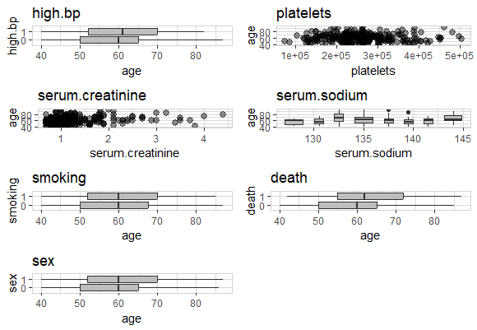

5. High bp vs. Age- The patients whose age are lower, that is from 50 to 65 years old, do not experience heart attacks even though they have high blood pressure. However, patients with age from 55 to 70 years old experience heart attacks.

6. Smoking- The patients with age range from 50 to 67 years do not experience heart attack and patients with age range from 55 to 70 experience heart attack which means higher age people are more prone to heart attack.

7.Sex vs. Age- Higher is the age more is the intensity to to have heart attack.

8.Death - more is the age , patient are more prone to heart attack which causes death of the patients.

9. Serum creatinine vs. age- Serum creatinine is mainly used to find kidney failure but its increased levels also contribute to heart failure.

10. Serum sodium vs. age- lower levels of sodium have an increased risk of death and cause heart failure.

11.Platelets vs. Age- high platelets count can contribute to the formation of clots within the coronary artery and therefore risk of heart failure increases.

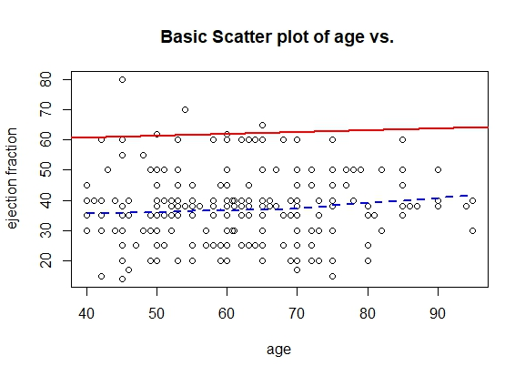t

The above graph shows how the ejection fraction varies with age . The majority of the patients are between 40 and 50% ejection fraction and are borderline to experience the heart failure . The amount of blood pumped out by heart is good indicator of the chances of heart failure .

All 12 variables are compared with each other in following graphs .

